

Clinical Knowledge Manager Template Review

General Guidance

****© 2017 freshEHR Clinical Informatics Ltd.**

*Readers may share and adapt the material in this document under the Creative Commons Attribution-ShareAlike (CC BY-SA) licence.*

*Whilst freshEHR Clinical Informatics Ltd. makes every effort to ensure the accuracy of the information contained in this document, it cannot accept responsibility for any claim, loss or damage which may occur from the use of the information in this document.*

*freshEHR Clinical Informatics Ltd. reserves the right to change the content of this document without prior notice.*

**freshEHR Clinical Informatics Ltd.**

**6 Packer Road**

**Kettering**

**NN15 7RP**

Website: [www.freshehr.com](http://www.freshehr.com)

Table of Contents

1. Introduction 4

2. General information 4

3. Invitation 5

4. Review template now 5

4.1. Overview 5

4.2. Simple view 6

4.3. Starting the review 7

4.4. The Header tab 7

4.5. The Data tab 8

4.6. Special questions 9

4.7. The Overall Comments tab 10

5. The Dashboard 12

# Introduction

This document provides some brief guidance notes on how to carry out a template review in the Clinical Knowledge Manager tool.

# General information

One of the key points to be aware of at this stage is that you will be reviewing a dataset rather than finished data entry form or report. The dataset is represented in such a way that it looks like a form, but the user interface for an actual form or the format of an actual report based on this dataset may look quite different. So what does that mean for you as a reviewer?

* The order in which individual data items are displayed may not feel right. This can be due to the way in which the underlying dataset artefacts are structured, and the order can be changed later in the user interface.
* There will be some additional information such as descriptions of data points or seemingly redundant headings which again are part of the underlying artefacts and may not be required in the final user interface. They are, however, helpful to understand the structure of the dataset and the meaning of the individual data points.

The invitation email you received contains some information about the project itself, and some suggestions of what you should be looking out for. In general, we would like reviewers to keep the following in mind when doing a review:

* Is the clinical content correct?
* Is anything missing?
* Is any of the content superfluous?
* Does the content match current practice / pathways you use?
* Are the names of the individual data points meaningful?

And obviously, we’ll be grateful if you point out any spelling mistakes or grammar issues.

Don’t write things like ‘Ok’ or ‘Agree’ or ‘I like it’ in the comments when you do your review. Much as we like it when you agree with what we have done, someone has to read and action all the comments once the review round is completed, and these sorts of comments just waste time. If we don’t see any comments against a particular item, we assume it’s ok.

You can add as many or as few comments as you like. All comments are entirely optional, and there is only one bit we need you to complete before you submit your review, and that is at the very end of the process when we ask you for your overall recommendation. I’ll say a bit more about this at the end of this document.

# Invitation

You will have received an email invitation to review a template. In the body of the email there will be four choices:

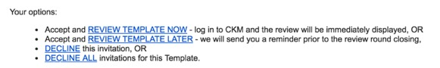

If you are ready to review the template you should select ‘***Accept and review template now’***. This will take you to the relevant page for this review in Clinical Knowledge Manager (see Section 4).

If you want to be involved in the review but you don’t have time right now, you can select ‘***Accept and review template later***’. You will receive a reminder shortly before the review period expires. You can also review the template at any time by simply logging onto Clinical Knowledge Manager and using the dashboard to find the review (see Section 5).

If you don’t want to be involved in this review round, you can select ‘***Decline this invitation***’. You may get another invitation later if there is another review round for the same template.

If you don’t want to review this template at all, you can select ‘***Decline all invitations for this template***’. You may get an invitation in the future to participate in a review for another template or archetype.

# Review template now

## Overview

When you have chosen to perform the review now from your invitation email, you will be presented with the Clinical Knowledge Manager login screen. Enter your login name and password. Your login name is usually in the format firstname.surname and was allocated when you first signed up to Clinical Knowledge Manager.

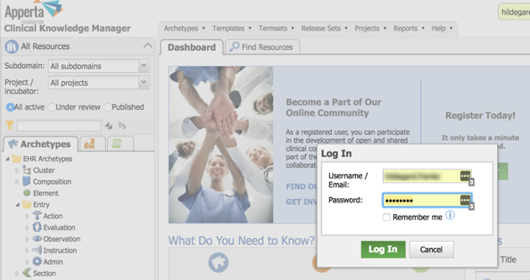

Once you have signed in, the template review screen will be displayed.

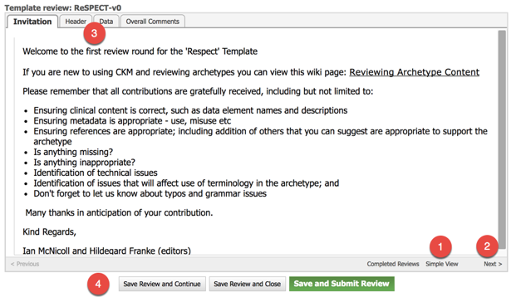

You now have several choices:

1. Display a simple view of the template to get an overview of the content.
2. Move to next tab to start reviewing the template.
3. Use the tabs at the top to navigate through the different parts of the review.
4. The buttons at the bottom are available at any time during the review process and can be used to ***save and continue***, ***save and close*** or ***save and submit the review***. Note that the last one should only be used when you have completed the review.

## Simple view

Before you start the review process it may be useful to switch to the simple view of the template, just to see a more compact view of the content. This will be displayed in a separate tab (see (1) in the screenshot) to allow you to toggle back and forth between the simple view and the review screen.

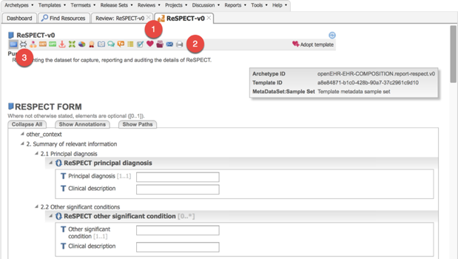

As well as looking at the simple view itself, you can also switch to a printable view (2) or a mindmap view (3). Either of these may be helpful to understand and visualise the content of the template.

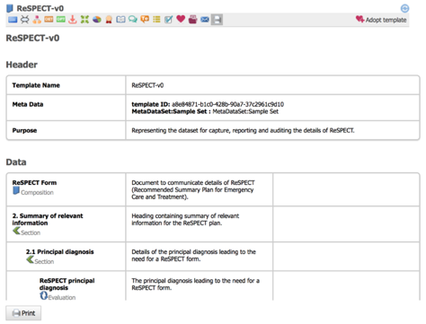

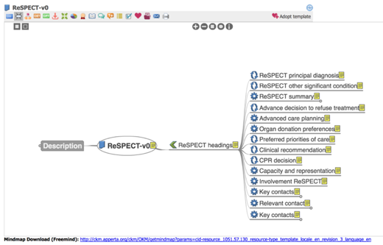

## Starting the review

To start the review, just toggle back to the review screen and click on ***Next*** at the bottom of the screen or select the Header tab.

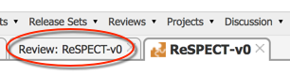

## The Header tab

The Header tab displays the template name and the purpose of the template. You can add comments on both by simply typing into the box entitled ‘Your Comment’.

When you have finished with your comments or if you have no comments on the Header, click on Next or select the Data tab to move to the main body of the template.

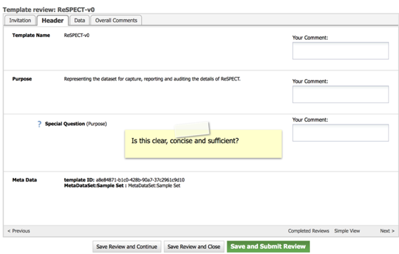

Below are a couple of examples of typical comments made on the Header details in other template reviews:

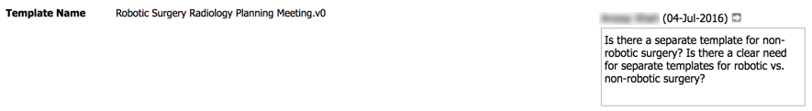

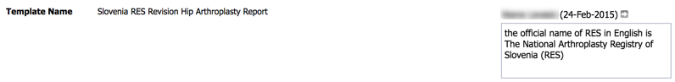

## The Data tab

The Data tab displays the main body of the template. This part is quite long, so here are some useful hints:

1. The body of the template has four columns:
2. The name of the data point (e.g. *Principal diagnosis, Interpreter required, Date of decision*).
3. The description of the data point (e.g. *The name of the principal diagnosis, preferrably coded, e.g. 'Bronchial carcinoma'*).
4. Details of picklist values, units of measure, minimum/maximum values, default values. This column is often empty where no constraints have been applied.
5. The Comments box where you can add your comments, suggestions or questions.
6. Some of the lines just reflect the underlying structure and do not actually contain any clinical data as such. Examples of these are



screenshots/2017-02-25_18-30-18_01.jpgThere is no need for you to comment on these lines.

1. screenshots/2017-02-25_18-30-18_01.jpgscreenshots/2017-02-25_18-30-18.jpgThese structural lines are coloured differently and have a black triangle icon which you allows you to hide the details underneath once you have finished commenting on it. You can unhide the details by clicking the white triangle icon next to a closed section.
2. screenshots/2017-02-25_18-30-18.jpgClosing each part with the black triangle icon once you finish reviewing that part may be helpful as you go through the review. You can always reopen it with the white triangle icon .
3. You don’t have to complete the review in one go. The icon allows you to save what you’ve done so far and come back to it later by logging back into Clinical Knowledge Manager and selecting the review through the Dashboard (see Section 5).

Below are some examples of typical comments on other template reviews:

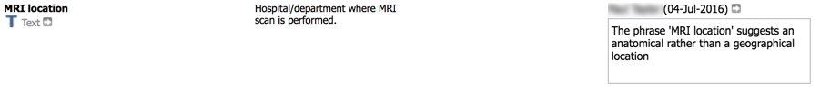

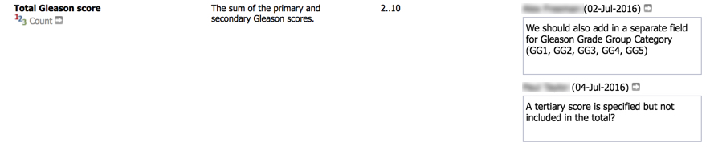

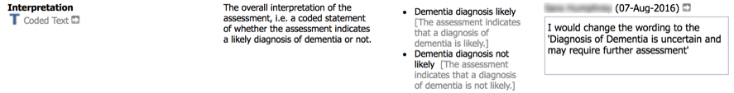

When you have reviewed the whole body of the template and added your comments, questions or suggestions, click on ***Next*** or select the ***Overall comments*** tab to move to the final step of the review.

## Special questions

In the course of your review you may come across ‘special questions’.

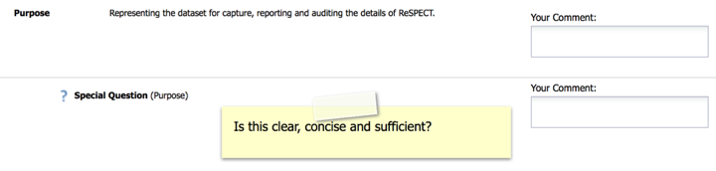

These are often prompts to provide some additional information on a particular data point or element of the template, and it would be very helpful if you can pay special attention to these.

## The Overall Comments tab

The final part of the review allows you to make some more general comments about the template and complete the overall recommendation.

As with the previous section, comments are optional, and you don’t have to add anything.

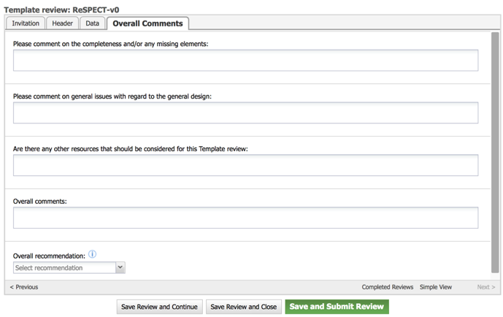

Below are some examples of overall comments made in other template reviews:

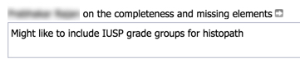



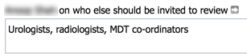

The ***Overall Recommendation*** is mandatory, and this is the only part you must complete if you want to submit your review. You must select one of these options:

**Accept**

**Minor revision**

**Major revision**

**Reject**

**Abstain**

The screenshot below explains how these options are intended to be used. You can also display this information by clicking on the icon next to the ***Overall Recommendation*** field.

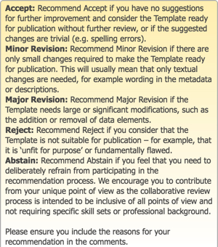

# The Dashboard

If you want to go back to your review later or you have selected to accept a review but complete it later, you can log into the Clinical Knowledge Manager ([http://ckm.apperta.org/ckm/)](http://www.clinicalmodels.org.uk/ckm/)) and select the Dashboard tab.

By default, the top left hand quadrant displays any outstanding reviews. Click on the line displaying your review and select ***Start your review now***.

